The Present Perfect Progressive Tense

A. First, review the forms of the present perfect progressive tense.

I have (I’ve)  We have (We’ve)  You have (You’ve)  They have (They’ve)  She has (She’s)  He has (He’s)  It has (It’s) | + been | - the verb in its simple form*  *You may need to delete the final e or double the final consonant. | + ing

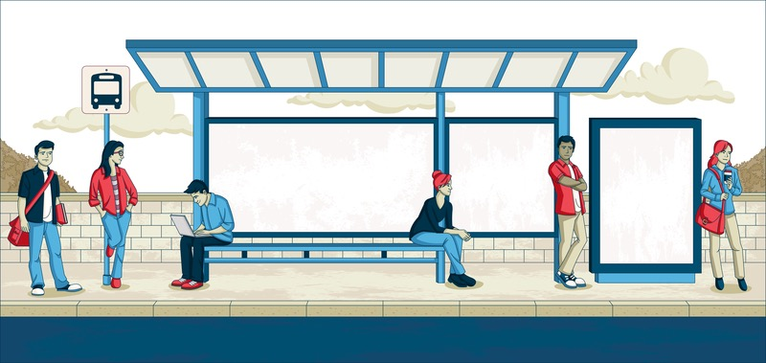
B. Look at the drawing above. Where are these people? Where are they going? How do they feel?

C. Read the conversation between Person A and Person B on the next page. Fill in each blank with the present perfect progressive form of the verb in the first column. Then read the conversation aloud with a partner.

Copyright © 2019 Sandra Heyer. All rights reserved. Permission granted to reproduce for classroom use. Photo: Copyright © Deniscristo | Dreamstime. Reprinted with permission
wait | A. I __________________________________ for the Number 31 bus for fifteen minutes. Are you waiting for the Number 31, too?
wait | B. No, I’m waiting for the Number 6. I __________________________________ for twenty minutes.
run | - I wonder what’s going on. My bus is usually on time, but this week  it __________________________________ late.
arrive | B. For the last month, my bus __________________________________ late every day. But it’s never been this late.
ride | - My sister used to take the bus. But her bus was really late last Friday, and  she __________________________________ the subway ever since. She says the buses are too undependable.
use | B. My brother says the same thing. He doesn’t take the bus anymore, either. Lately  he __________________________________ Uber or Lyft.
get | - I might do that, too. The bus used to be great. But this week  I __________________________________ to work late.
take,  miss | B. I know what you mean. I __________________________________ the bus to the university all semester. But lately I __________________________________ the beginning of class.
think | A. I __________________________________ about buying a car. Hey–if I do, would you like a ride? I work near the university.
 | B. That would be great. My name’s Caitlin, by the way.
 | A. I’m John.
 | B. Here come our buses! Let me give you my number. Give me a call if you buy a car.
 | A. I will. Bye, Caitlin.
 | B. Bye, John.

D. What do you think will happen next? Write the ending to this story in the space below.

