Verb Tenses in the Song "Tucson Train" by Bruce Springsteen

A. Bruce Springsteen is a songwriter, singer, and guitarist. Imagine that a reporter is interviewing him. Read the reporter's questions and Springsteen's answers. Notice the tenses he uses in his answers.

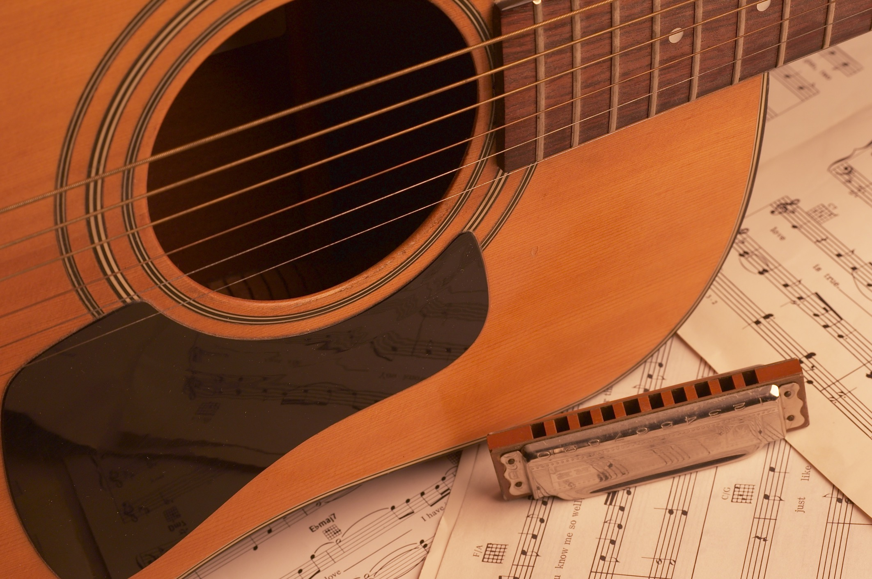
B. Work with a partner. One person reads the reporter's questions aloud. The other person reads Springsteen's answers aloud.
Reporter’s Question | Springsteen’s Answer | Verb tense
1. How often do you play the guitar? | I play the guitar every day. | Simple present
2. What are you doing right now? | I am (or I’m) playing the guitar. | Present progressive
3. What did you do yesterday? | I played the guitar. | Simple past
4. How long have you played the guitar? | I have (or I’ve) played the guitar for many years. | Present perfect
5. When will you play the guitar in a concert? | I will (or I’ll) play the guitar in a concert next week. | Future

Activity on this page: © Sandra Heyer, 2019. Permission granted to duplicate for classroom use.
Photo of guitar: © William Brodt | dreamstime. Used with permission.

C. Write the missing verbs in the song lyrics below. Use the correct verb tense.

1. (get, simple past) | I _________got________ so down and out in San Francisco.
2. (pick, simple past) | I ____________________ up, and
3. (head, simple past) | I ____________________ for the sunshine.
4. (leave, simple past) | I ____________________ a good thing behind.
5. (seem, simple past) | It ____________________ all of our love was in vain.
6. (come, simple past) | I ____________________ here looking for a new life, one I wouldn't have to explain
7. (keep, simple present) | to that voice that____________________ me awake at night.
8. (fight, simple past) | We ____________________ hard over nothing.
9. (remain, simple past) | We fought until nothing ____________________.
10. (carry, present perfect) | I ____________________ that nothing for a long time.
11. (carry, simple present) | Now I ____________________ my operator's license.
12. (spend, simple present) | I ____________________ my days just running this crane.
13. (clear, future) | Hard work ____________________ your mind and body.
14. (burn, future) | The hard sun ____________________ out the pain.
15. (look, present progressive) | If they ____________________ for me, tell them
16. (wait, present progressive) | I ____________________ down at the station.
17. (come, present progressive) | My baby ____________________ in on the Tucson train.

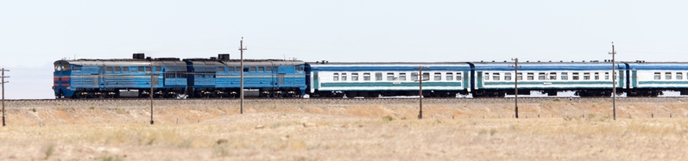

Lyrics from "Tucson Train" by Bruce Springsteen
Photo of train: © Andrei Shupilo | dreamstime. Used with permission.

Answer Key

- got
- picked
- headed
- left
- seemed
- came
- keeps
- fought
- remained
- have carried
- carry
- spend
- will clear
- will burn
- are looking
- am waiting
- is coming

D. Complete questions 1, 4, and 5. (There are many possible ways to complete the questions.) Then ask a partner the questions below.

- How often do you _________________________________________?
- What are you doing right now?
- What did you do yesterday?
- How long have you _________________________________________?
- When will you _________________________________________?

