Participial Phrases, Part 2

A. Read the sentences next to the photo. Notice the comma between the words garden and planting in the one-sentence answer. The comma makes it clear that the phrase planting vegetables refers to Grandfather (He), not to the garden.

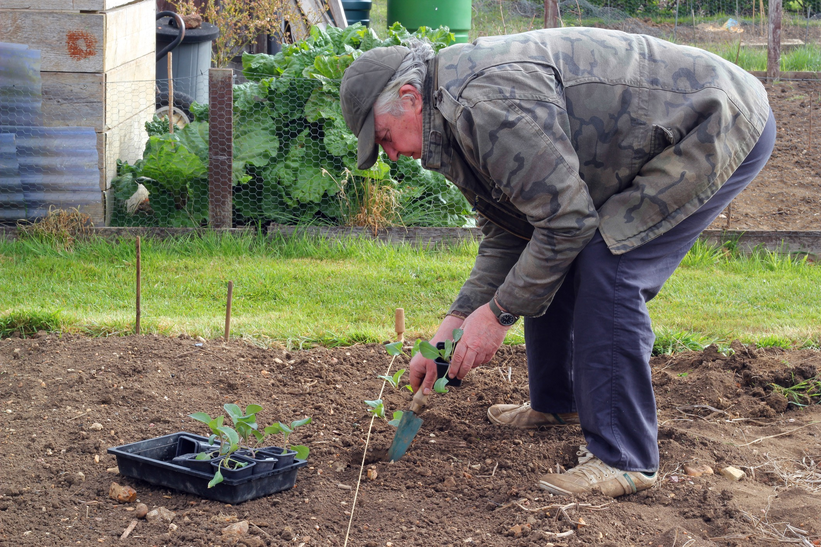
Question: Where’s Grandfather?

Answer in two sentences: He’s at the community garden. He’s planting vegetables.

Answer in one sentence: He’s at the community garden, planting vegetables.

B. Combine the sentences in Column B to make one sentence. Write your new sentence in Column C. (Don’t forget the comma.)

A. Question | B. Answer in two sentences | C. Answer in one sentence
1. Where was Sam yesterday? | He was in the kitchen all afternoon.  He was making food for the party. | He was in the kitchen all afternoon, making food for the party.
2. Is Emma in Europe? | Yes, she’s at a university  in France.  She’s studying French.
3. Where was Jack this morning? | He was at the gym downtown.  He was playing basketball.
4. Where were you yesterday? | I was home all day.  I was painting the living room.

A. Question | B. Answer in two sentences | C. Answer in one sentence
5. Where’s the manager? | She’s in her office down the hall.  She’s making a phone call.
6. Who’s Annie? | She's the woman with short hair and glasses.  She’s sitting next to  the window.
7. Did you see Silvia and Marco  at the mall? | Yes, I saw them in the mall parking lot.  They were carrying a lot of packages.

C. Read the questions in Column A and the answers in Column C aloud with a partner.

D. Answer the questions below in complete sentences. Write your answers on the lines.

1. Where were you yesterday at 8 PM?

__________________________________________________________________

2. What were you doing?

__________________________________________________________________

E. Combine your two sentences to make one sentence. Here are some examples:

I was at my aunt’s house, learning how to make chicken soup.
I was in the garage, trying to fix my car.

Write your new sentence on the line below.

_____________________________________________________________________

F. Share your sentence with the class.

Copyright © 2017 Sandra Heyer. All rights reserved. Permission granted to reproduce for classroom use.
Photo: Copyright © Clearvista | Dreamstime. Reprinted with permission.

