I’ve Got It and I’ve Got ‘Em

1. Two people are packing for a trip to the United States. They are going to study at a university in Wisconsin, and they know the weather will be cold. They are checking to be sure they have everything.

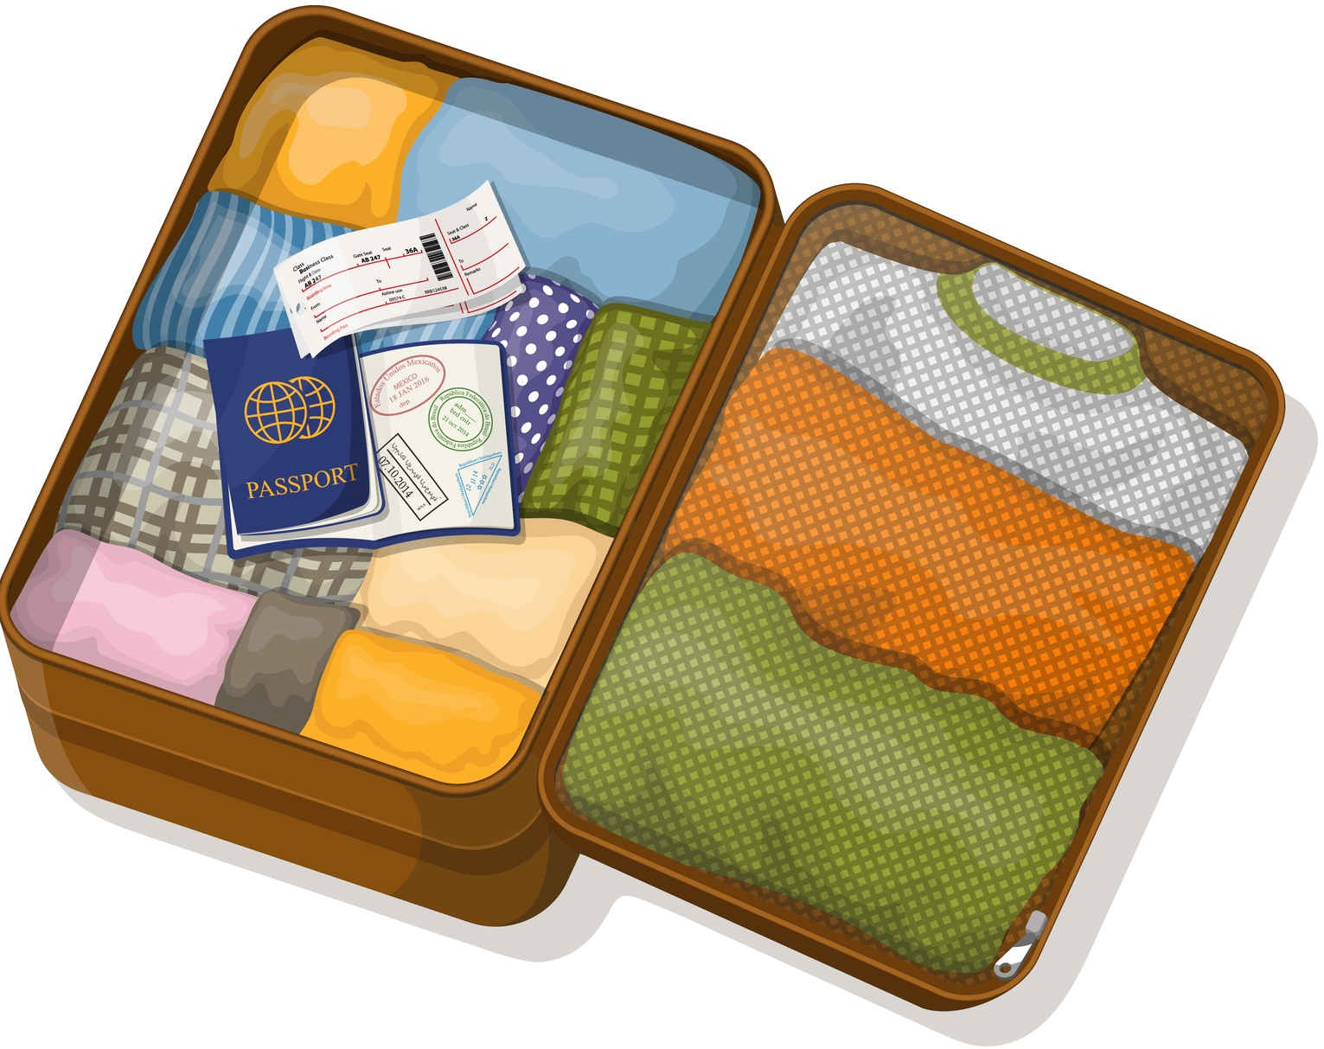
Read their conversation.

Person 1: Do you have a hat?
Person 2: I’ve got it.
Person 1: Do you have gloves?
Person 2: I’ve got ‘em.¹
¹ In informal spoken English, usually people don’t say the th in them—they say ‘em. (Also, sometimes they don’t say the ‘ve in I’ve got—they say I got.)

2. Imagine that you are packing for a trip to Wisconsin. You are checking to be sure you have everything.

Work with a partner. Person 1 asks about each item on the checklist. (For example, Do you have a hat?) Person 2 looks at the list of things
Person 2 has. If the answer is no, Person 2 says No. If the answer is yes,
Person 2 says I’ve got it or I’ve got ‘em. Then trade roles. (There are two items that nobody has.)
Checklist

☐ a hat | ☐ cash | ☐ a charger
☐ a warm jacket | ☐ a credit card | ☐ a notebook
☐ gloves | ☐ a passport | ☐ pens
☐ a scarf | ☐ a cell phone | ☐ walking shoes

Person 1 has… Person 2 has…

a cell phone cash
a charger a credit card
a passport gloves
pens a hat
a warm jacket walking shoes

Copyright © 2016 Sandra Heyer. All rights reserved. Permission granted to reproduce for classroom use. Photo: Copyright © Stashom | Dreamstime. Reprinted with permission.

