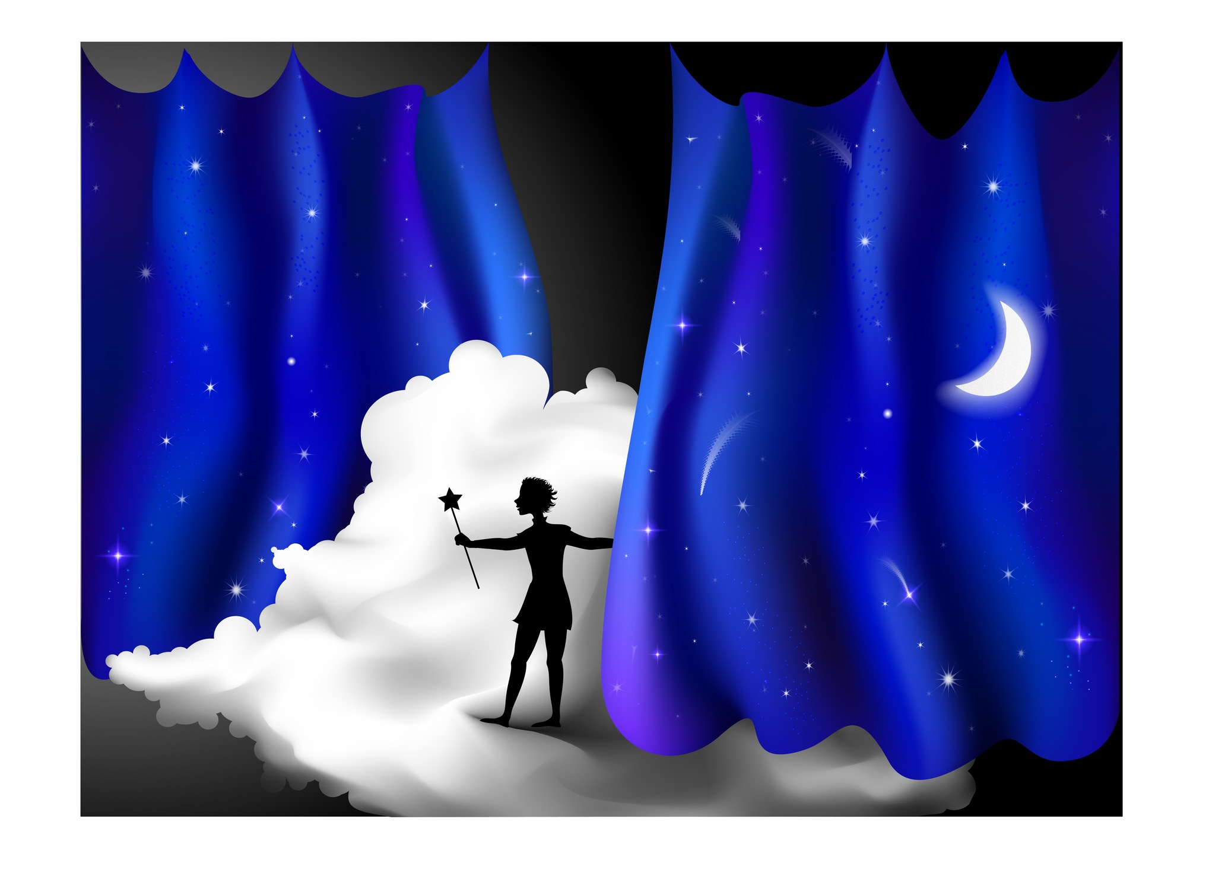
Finding Your Neverland

Ruth couldn't stop thinking about Neverland.

Neverland is a magical place in a play called Peter Pan. Peter Pan is the main character in the play. He is a boy who is special for two reasons: He can fly, and he will never grow old. He will always be a boy. Neverland is Peter’s home.

Other characters live in Neverland, too. Tinkerbell is a fairy who sprinkles Peter Pan with "fairy dust" when he wants to fly. Captain Hook is a pirate who wants to kill Peter. The Lost Boys are Peter’s friends. Wendy Darling is a girl who visits Neverland.

After Ruth watched a TV program about Peter Pan, she kept thinking about Neverland. It gave her the idea for a song. “I am a lost boy from Neverland, usually hanging out with Peter Pan,” she sang. Ruth shared six seconds of her song on the Internet. The clip got 84,000 likes. "Write more!” people told Ruth.

Ruth was a busy college student, and she didn't have much time to write music. But every day after classes, she wrote one more line of the song. When it was finished, she gave her song the name “Lost Boy” and made a video. In the video, she played her keyboard and sang the song. When she posted the video on YouTube, it got millions of views. A record company recorded Ruth's song, and “Lost Boy” became a big hit.

The play Peter Pan was written in 1904. More than one hundred years later, the story inspired Ruth to write a song. Ruth’s song is about a lonely boy, Peter Pan, and Neverland. “But it's about more than that,” Ruth says. “It's about finding something that helps you when you feel lonely or sad. For me, it's music. But it can be a person, a hobby, a sport–anything that makes you feel at home. Feeling at home—that’s Neverland.”

Maybe the idea of Neverland is like Peter Pan. It never gets old.

Story: Copyright © 2016 Sandra Heyer. All rights reserved. Permission granted to reproduce for classroom use.
Photo: Copyright © Nadiaforkosh | Dreamstime.com. Reprinted with permission.

