Future with Will: Making Promises

When you make a promise, use I’ll or I will + the simple form of a verb.
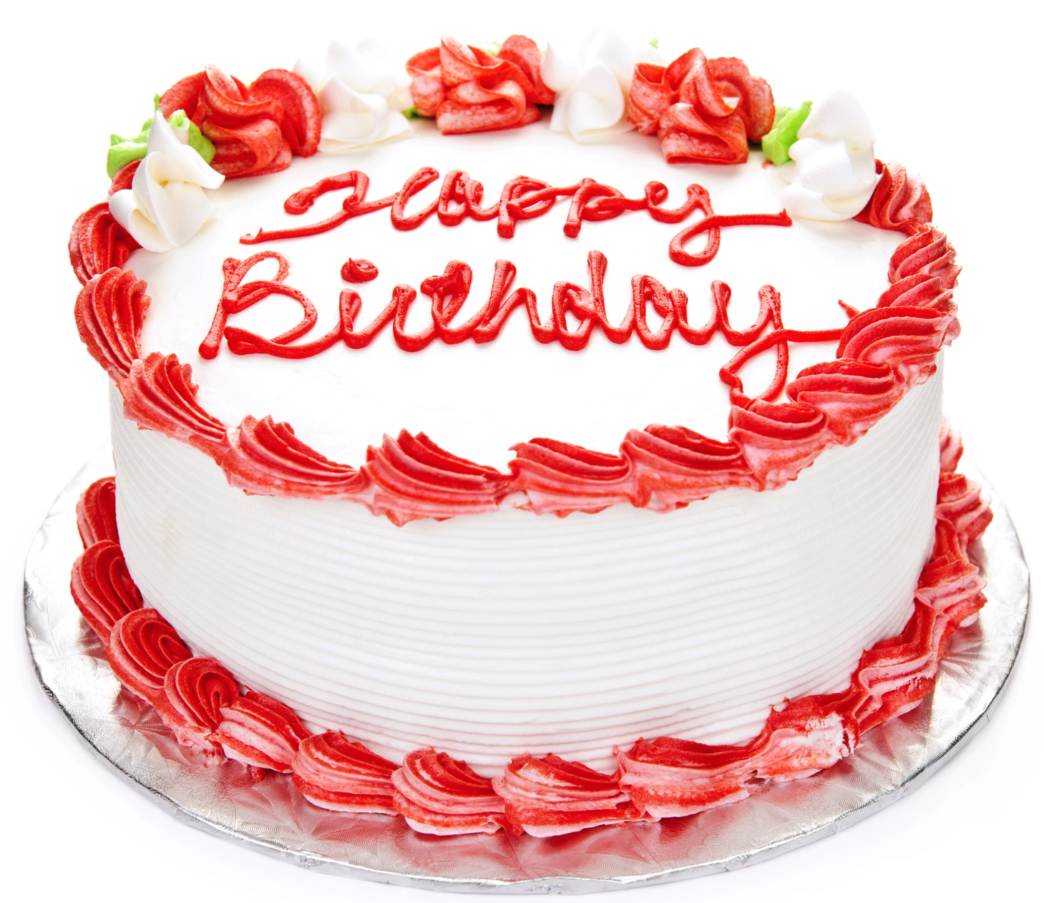
For example:

Person 1: Can you pick up the birthday cake at the bakery?

Person 2: I’ll pick it up on my way home.

- Imagine that you are Person 2 in the chart below. Write promises. Begin each sentence with I’ll, and write when you are going to keep your promise. (For example: right now; tomorrow; later; this morning / afternoon / evening; next week; after lunch / dinner/ school / work) Then read the sentences aloud with a partner.

Person 1 | Person 2
1. Can you help me fill out this form? | I'll help you this afternoon.
2. Can you take the children to the park? | I’ll take them after lunch.
3. Can you clean the kitchen?
4. Can you send me the information?
5. Can you buy snacks for the party?
6. Can you help me paint the living room?
7. Can you fix this broken lamp?
8. Can you translate this document?
9. Can you mail this package?
10. Can you show me how to use this computer?
2. When people get married, they often make promises to each other. Read the promises below. Choose the five most important promises. Put a check next to your choices. (You can also write your own idea on the line below.) Then explain to a partner why you chose those five promises.

☐ I will stay with you during difficult times.

☐ I will always put you first. (You will be the most important part of my life.)

☐ I will say "I love you" often.

☐ I will never try to change you.

☐ I will stay with you for the rest of my life.

☐ I will never say anything bad about your family.

☐ I will eat anything you cook.

☐ I will give you compliments.

☐ I will always be polite to you. (I will say please and thank you, for example.)

☐ I will not let myself go. (I will take care of my body.)

☐ Before I buy something expensive, I will talk it over with you.

☐ I will always be honest with you.

☐ I will be a good friend to you.

☐ ________________________________________________________________
(Write your own idea.)

Copyright © 2016 Sandra Heyer. All rights reserved. Permission granted to reproduce for classroom use.
Photo of cake: Copyright © Elena Elisseeva | Dreamstime. Reprinted with permission.

