TO GET TO DO SOMETHING
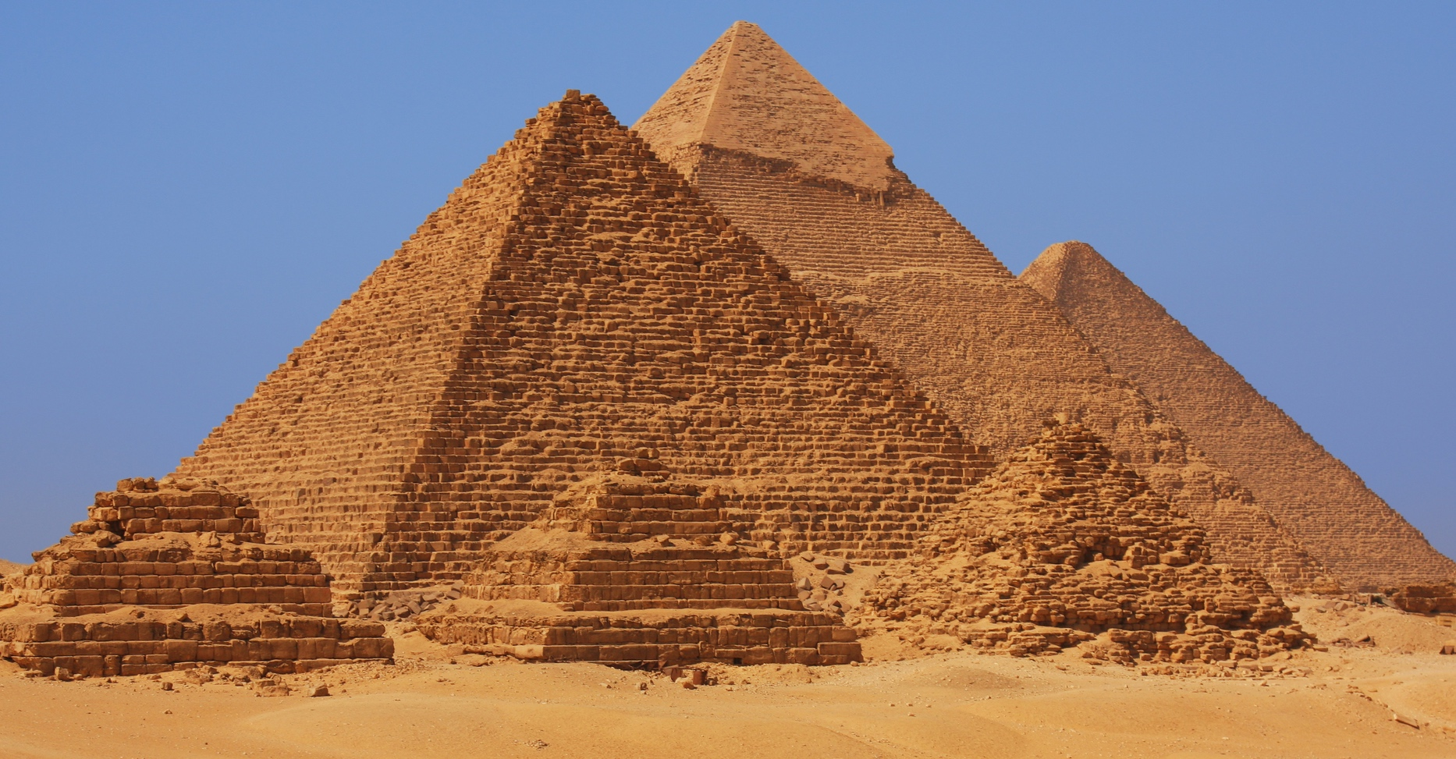

1. Read the conversation below.

Person 1: I’m going to Egypt.
Person 2: Will you get to see the Pyramids at Giza?
Person 1: I hope so.
When get to is followed by a verb in the simple form, it means “have the opportunity to.”
2. Match the places and the famous landmarks. Write the letter of your answer on the line.
A. PLACE | B. LANDMARK
1. Egypt __e__ | a. the Great Wall
2. Paris _____ | b. the Taj Mahal
3. China _____ | c. the Statue of Liberty
4. New York City _____ | d. the Eiffel Tower
5. India _____ | e. the Pyramids at Giza

3. Using the information in the chart above, have conversations with a partner. Follow this pattern:

Person 1: I’m going to ____________________. (a place in Column A)
Person 2: Will you get to see ____________________? (a landmark in Column B)
Person 1: I hope so.

4. In Column A in the chart below, write the name of a city or region in your country. In Column B, write the name of a famous landmark there. Your teacher will write your and your classmates’ information on the board.

A. PLACE | B. LANDMARK

5. Have more conversations with a partner using the information on the board.

Copyright © 2017 Sandra Heyer. All rights reserved. Permission granted to reproduce for classroom use.
Photo: Copyright © Dan Breckwoldt | Dreamstime. Used with permission.

